**Module - 17) Php - Introduction Of Laravel Php Framework – Industry**

Q-1) What is Laravel PHP Framework? Explain its key features?

Ans-1) Laravel is a popular open-source PHP framework designed to make web development faster, easier, and more enjoyable by providing a robust structure and various tools for building web applications. It follows the Model-View-Controller (MVC) architectural pattern, which separates the application logic, user interface, and database interactions, making development more organized.

* Key Features of Laravel:
* **MVC Architecture**: Laravel follows the MVC design pattern, which helps in separating logic (Model), design (View), and controlling part (Controller). This separation enhances maintainability, scalability, and readability of the application.
* **Eloquent ORM (Object-Relational Mapping):** Laravel provides an elegant and simple ORM called Eloquent, which makes database interactions more fluent and easy. It allows developers to work with databases using Active Record implementation and perform CRUD (Create, Read, Update, Delete) operations without writing raw SQL.
* **Blade Templating Engine:** Laravel includes a lightweight, powerful templating engine called Blade. Blade allows developers to create dynamic content and layouts by using simple syntax, including template inheritance and section management.
* **Routing:** Laravel provides a simple, expressive routing system. It allows developers to define routes in a straightforward manner using closure-based or controller-based methods.
* **Artisan CLI:** Laravel comes with a command-line tool called Artisan that helps automate repetitive tasks like database migration, seeding, creating controllers, and more. It also allows developers to create custom commands to streamline development tasks.
* **Database Migrations:** Laravel migration system provides a version control system for your database. You can easily manage database schema changes without manually editing database tables, allowing for smooth database updates and rollbacks.
* **Security:** Laravel provides several security features out-of-the-box, such as hashed passwords, protection against SQL injection, Cross-Site Scripting (XSS), and Cross-Site Request Forgery (CSRF). Its authentication and authorization systems are built-in and highly customizable.
* **RESTful APIs and API Development**: Laravel is ideal for building RESTful APIs. It provides tools like Passport and Sanctum to secure APIs, and with resourceful routing and API scaffolding, building APIs is efficient.

**Q-2)** Describe the advantages of using Laravel PHP Framework.

**Ans-2)** Advantages of Laravel PHP Framework:

* **Modular Design**: Laravel modular design allows developers to build scalable and maintainable applications.
* **Easy Routing:** Laravel provides a simple and expressive routing system, making it easy to define routes and handle requests.
* **Eloquent ORM:** Laravel Eloquent ORM provides a simple and elegant way to interact with databases, eliminating the need for complex SQL queries.
* **Blade Templating Engine:** Laravel Blade templating engine allows developers to create reusable templates and simplify view rendering.
* **Security:** Laravel provides robust security features, including authentication, authorization, and CSRF protection.
* **Artisan Console:** Laravel Artisan console provides a powerful command-line interface for tasks such as migration, seeding, and caching.
* **Large Community:** Laravel has a large and active community, ensuring extensive documentation, tutorials, and community support.
* **Extensive Libraries:** Laravel provides a range of libraries and tools for tasks such as email, file uploads, and queue management.
* **Unit Testing:** Laravel provides built-in support for unit testing, ensuring reliable and maintainable code.
* **Flexibility:** Laravel allows developers to customize and extend its functionality using packages and service providers.
* **Industry Benefits:**
* **Faster Development:** Laravel simplicity and modularity speed up development.
* **Improved Code Quality:** Laravel features promote maintainable and readable code.
* **Enhanced Security:** Laravel security features protect applications from common vulnerabilities.
* **Scalability:** Laravel modular design supports large-scale applications.
* **Cost-Effective:** Laravel reduces development time and costs.

**Q-3)** Explain the concept of MVC (Model-View-Controller) architecture in Laravel.

**Ans-3)** MVC based framework mainly divides the whole application into three components:

1) Model: It interacts with the database.

2) View: User Interface. It contains everything which a user can see on the screen.

3) Controller: It helps to connect Model and View and contains all the business logic. It is also known as the “Heart of the application in MVC”.

* Laravel MVC Structure

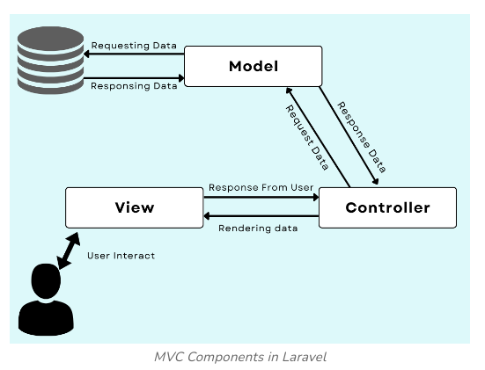

* **MVC Components in Laravel:**

In the above image, we can understand how the MVC framework interacts with the User and the Database.

* **Model:** This component of the MVC framework handles data used in your application. It helps to retrieve the data from the database and then perform some operation that your application is supposed to perform then it stores that data back in the database.

Model is responsible for managing data that is passed between the database and the User Interface (View).

* **View:** This component is User Interface, which defines the template which is sent as a response to the browser. This View components contain the part of code which helps to display data to the User Interface on the user’s browser. For example, we can say the buttons, textbox, dropdown menu, and many more such widgets on the browser screen are the part of View Component.
* **Controller:** This controller component helps to interact with the model component to fetch data from the database and then pass that data to the view component to get the desired output on the user’s browser screen. Same way, when the user enters some data the controller fetches that data and then performs some operation or just inserts that data into the database with the use of the model components.

Q-4 )Why MVC ?

Ans-4) It is mainly used to separate Application code into user interfaces, data, and controlling logic. It can benefit the developer to easily maintain the code which can help to make a development process much smoother.

Advantages of Using MVC framework:

* Organizing large-scale web application projects.
* Easier to perform Modification.
* Modification in any part won’t affect any other part of the code.
* Helps in a faster development process.
* Helps for Asynchronous Method Invocation.